Web Technologies

Task 6

(BSCS)

By
Sr | Name | Roll.  Number | Section
1 | Naeem Saleem | Fa-2023-Bscs-250 | G

Supervised by:

Mr. Muhammad yosaf



Department of Computer Science
Lahore Garrison University
Lahore

Lab 6: CSS Fundamentals & Box Model:

Lab Objectives
- Apply CSS rules to style a webpage.
- Understand and use the CSS Box Model.
- Use selectors, positioning, and layout techniques.
- Inspect and debug layout using browser DevTools.

Tools Required
- VS Code (with Live Server extension)
- Browser DevTools (Chrome, Firefox, etc.)
- A basic HTML portfolio page to style

Step-by-Step Tasks

🔹 Step 1: Style the Personal Portfolio

📄 HTML File (index.html) – Basic Structure
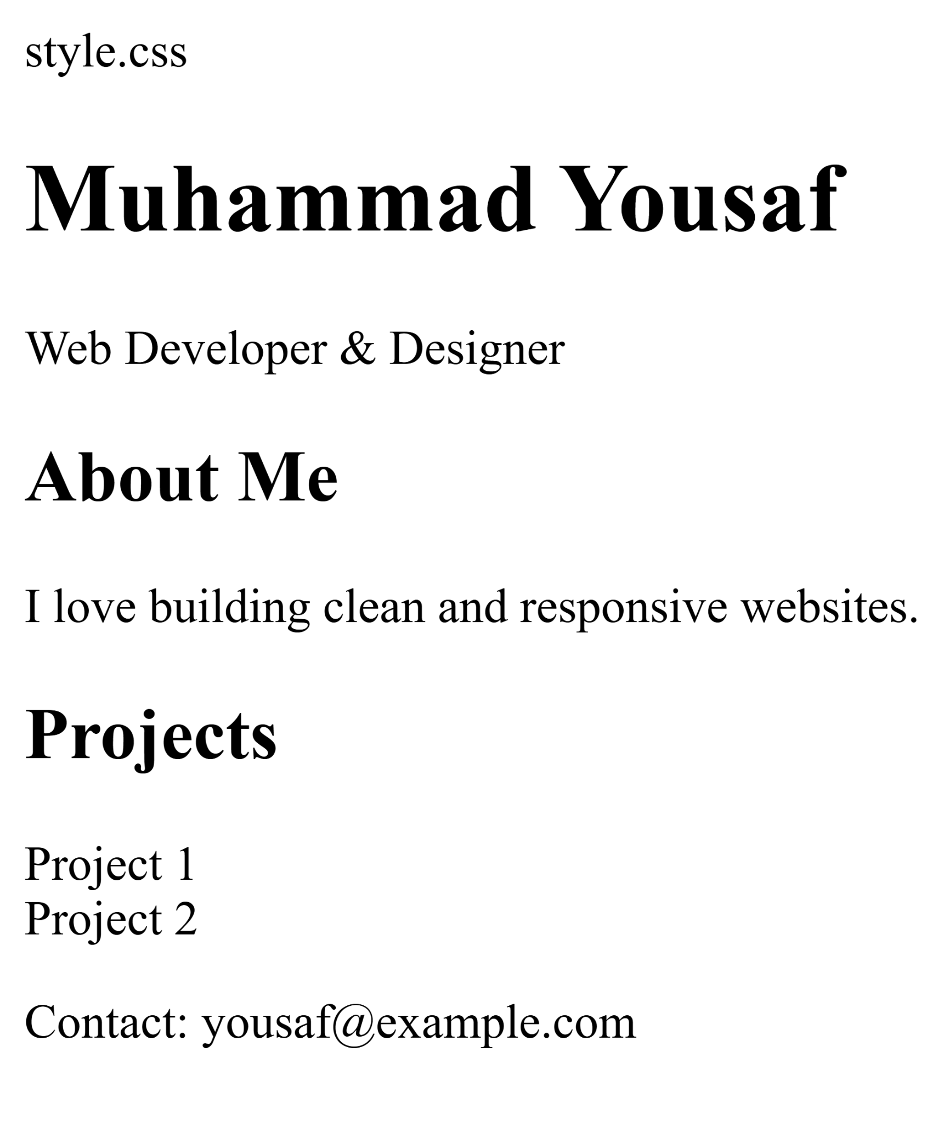

CSS File (style.css) – Styling and Box Model
/* General Reset /
{
box-sizing: border-box;
margin: 0;
padding: 0;
}

/* Body Styling /
body {
font-family: Arial, sans-serif;
background-color: #f4f4f4;
color: #333;
padding: 20px;
}

/ Header /
header {
background-color: #007acc;
color: white;
padding: 20px;
margin-bottom: 20px;
border-radius: 8px;
}

/ Class and ID Selectors /
#main-title {
font-size: 2em;
}

.tagline {
font-style: italic;
}

/ Section Styling /
.about, .projects {
margin-bottom: 20px;
padding: 15px;
background-color: white;
border: 1px solid #ccc;
border-radius: 5px;
}

/ Project Cards with Float /
.project-card {
float: left;
width: 45%;
margin: 2.5%;
padding: 10px;
background-color: #e0e0e0;
border: 1px solid #999;
border-radius: 5px;
}

/ Clearfix /
.projects::after {
content: "";
display: table;
clear: both;
}

/ Footer */
footer {
text-align: center;
padding: 10px;
background-color: #ddd;
border-radius: 5px;
}
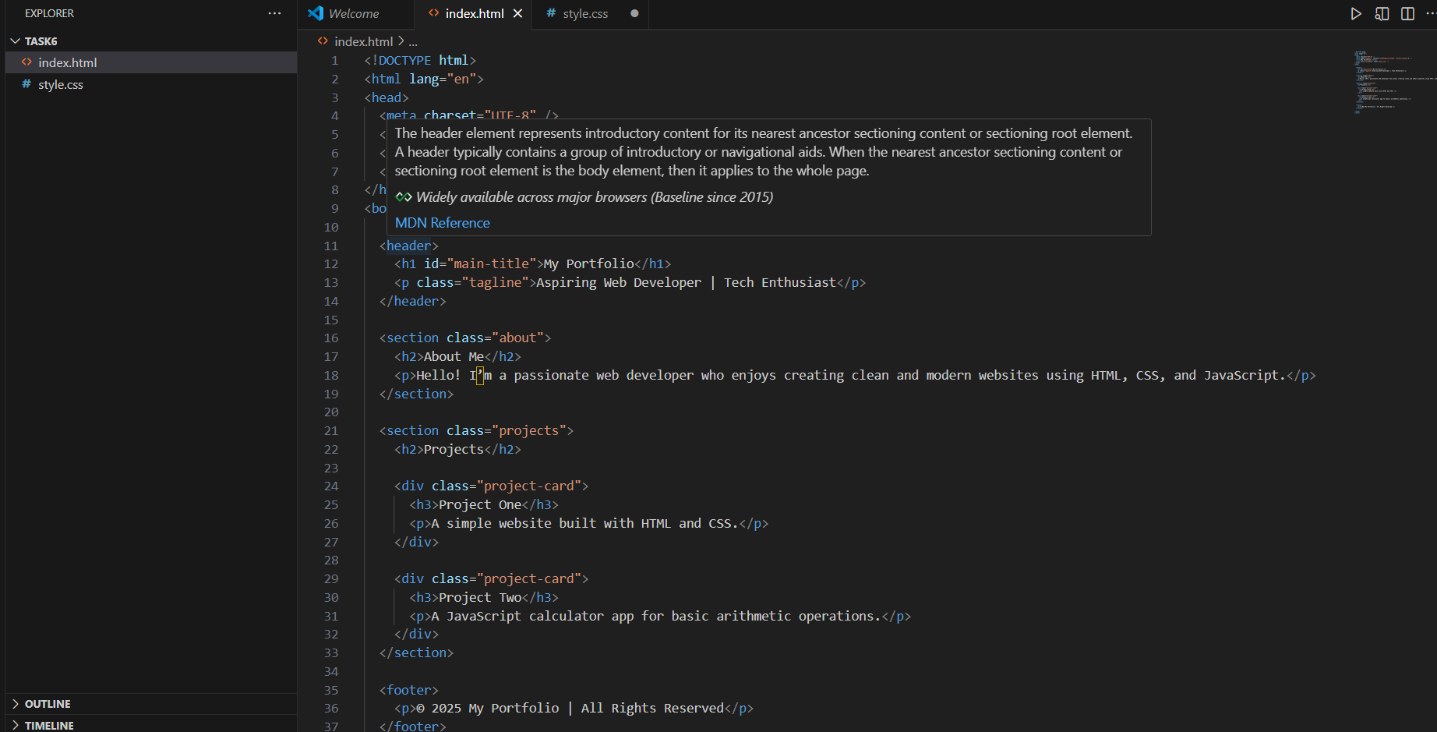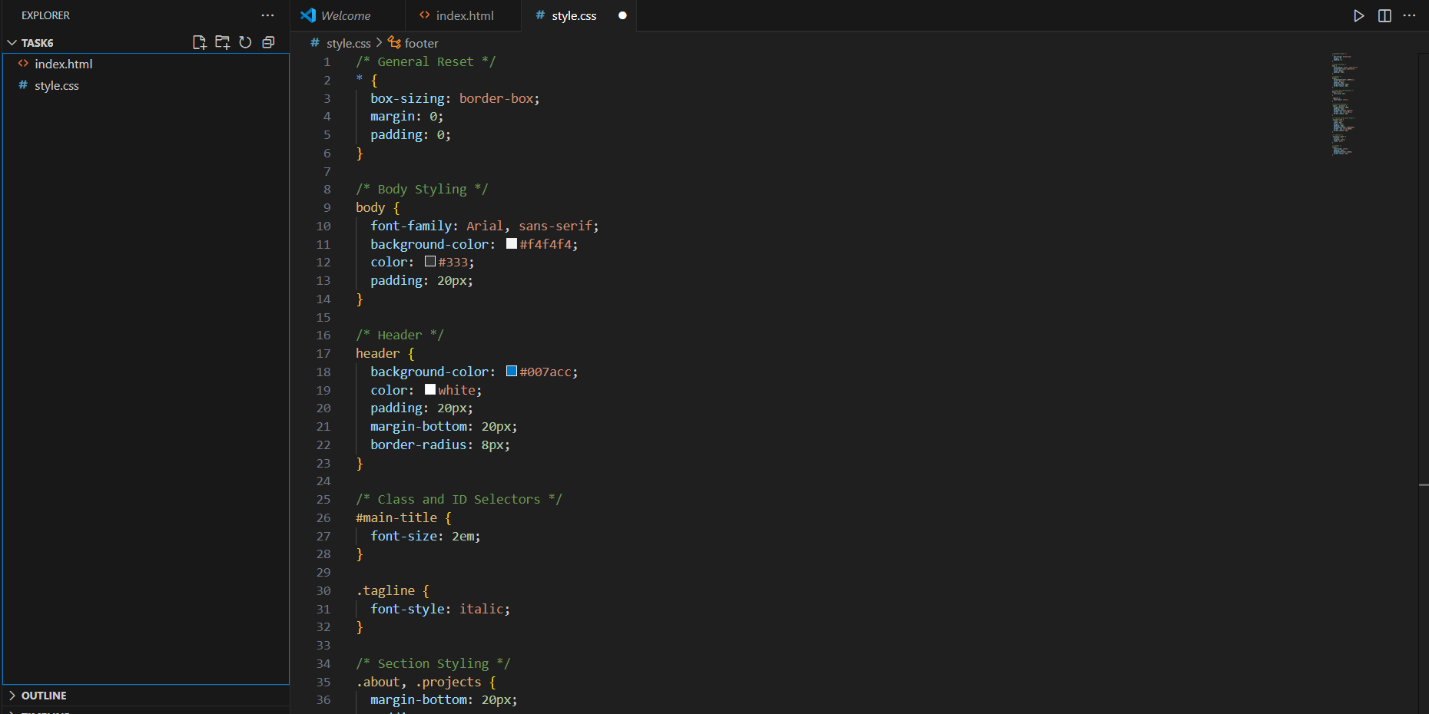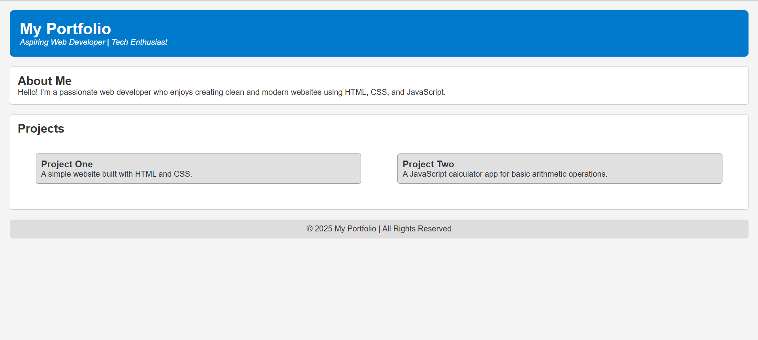

🔹 Step 2: Use Selectors and Layout Techniques
- ID Selector: #main-title
- Class Selector: .tagline, .project-card
- Descendant Selector: section .project-card
- Float and Clear: Used for .project-card and .projects::after
- Modern Alternative: You can replace float with Flexbox or Grid for responsive layouts.

🔹 Step 3: Use DevTools to Inspect Box Model

📘 How to Inspect:
- Open the page in a browser.
- Right-click on any element (e.g., .project-card) and choose Inspect.
- In the Elements tab, look at the Box Model section:
  - Check margin, border, padding, and content.
  - Adjust styles live to fix layout issues.
Deliverable: Take screenshots of the DevTools showing the box model for at least one element.
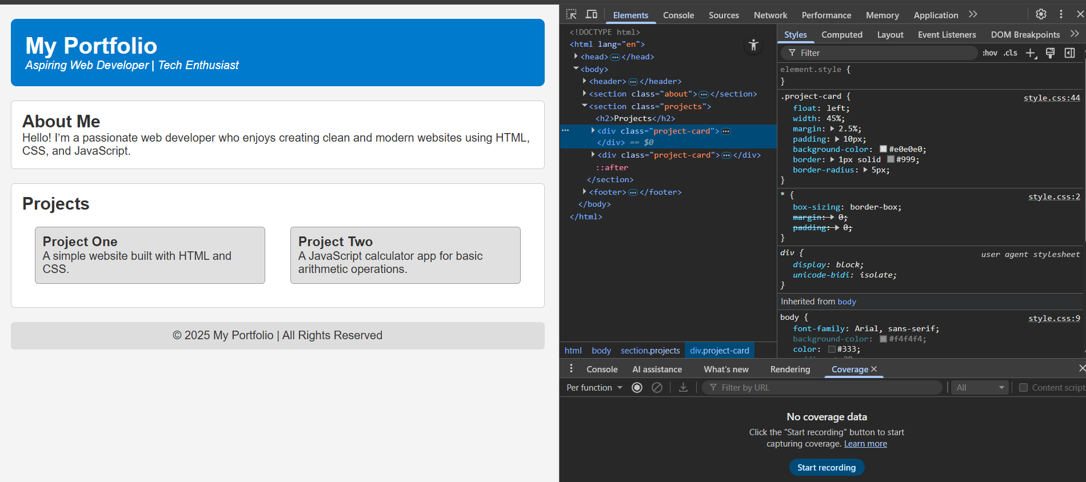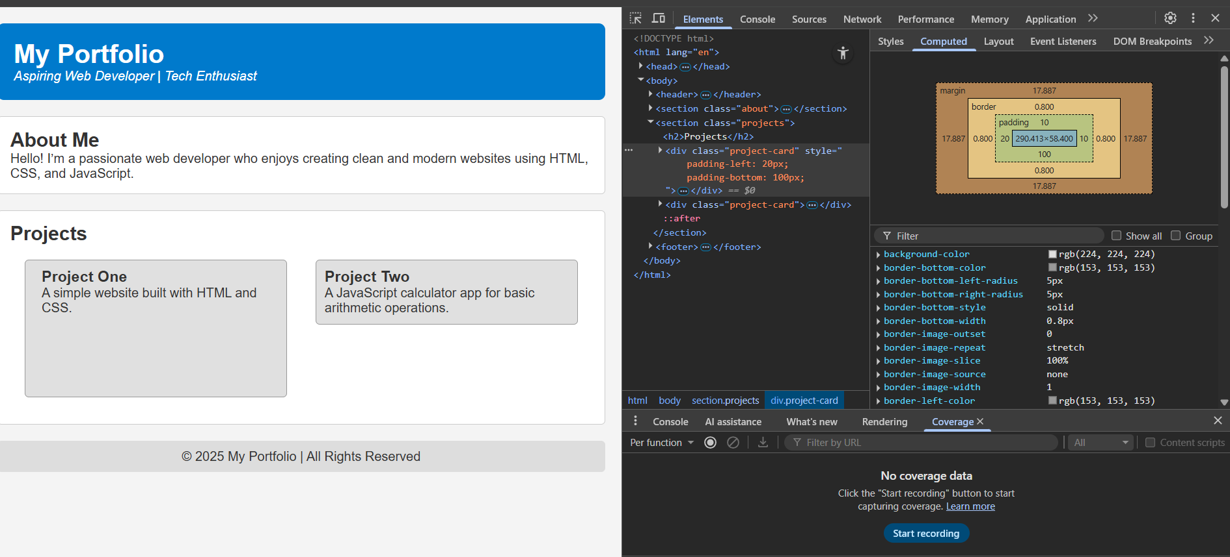

Final Deliverables
- index.html – Portfolio page
- style.css – CSS file with styling and layout
- Screenshots of DevTools showing box model inspection
Would you like me to generate a downloadable ZIP file with these files or help convert the layout to Flexbox/Grid for modern responsiveness?

CONCLUSION:
________________________________________________________________________________________________________________________________________________________________________________________________________________________________

RUBRICS:

Performance |  |  | Lab Report
Description | Total Marks | Marks Obtained | Description | Total Marks | Marks  Obtained
Ability to Conduct practical | 5 |  | Structure | 5
Data Analysis & Interpretation | 5 |  | Efficiency | 5
Total Marks obtained |  |  | Total Marks Obtained

Instructor Signature

